17-Mar-22

**Experiment 8 - Computation of leading and trailing**

Dhawal Patil

RA1911003010575

CSE A2

Aim:

To write a program to show Computation of leading and trailing using Python language.

Algorithm:

1. For Leading, check for the first non-terminal.
2. If found, print it.
3. Look for next production for the same non-terminal.
4. If not found, recursively call the procedure for the single non-terminal present before the comma or End Of Production String.
5. Include it's results in the result of this non-terminal.
6. For trailing, we compute same as leading but we start from the end of the production to the beginning.
7. Stop

Code:

a = ["E=E+T", "E=T", "T=T*F", "T=F", "F=(E)", "F=i"]

rules = {}

terms = []

for i in a:

temp = i.split("=")

terms.append(temp[0])

try:

rules[temp[0]] += [temp[1]]

except:

rules[temp[0]] = [temp[1]]

terms = list(set(terms))

print(rules,terms)

def leading(gram, rules, term, start):

s = []

if gram[0] not in terms:

return gram[0]

elif len(gram) == 1:

return [0]

elif gram[1] not in terms and gram[-1] is not start:

for i in rules[gram[-1]]:

s+= leading(i, rules, gram[-1], start)

s+= [gram[1]]

return s

def trailing(gram, rules, term, start):

s = []

if gram[-1] not in terms:

return gram[-1]

elif len(gram) == 1:

return [0]

elif gram[-2] not in terms and gram[-1] is not start:

for i in rules[gram[-1]]:

s+= trailing(i, rules, gram[-1], start)

s+= [gram[-2]]

return s

leads = {}

trails = {}

for i in terms:

s = [0]

for j in rules[i]:

s+=leading(j,rules,i,i)

s = set(s)

s.remove(0)

leads[i] = s

s = [0]

for j in rules[i]:

s+=trailing(j,rules,i,i)

s = set(s)

s.remove(0)

trails[i] = s

for i in terms:

print("LEADING("+i+"):",leads[i])

for i in terms:

print("TRAILING("+i+"):",trails[i])

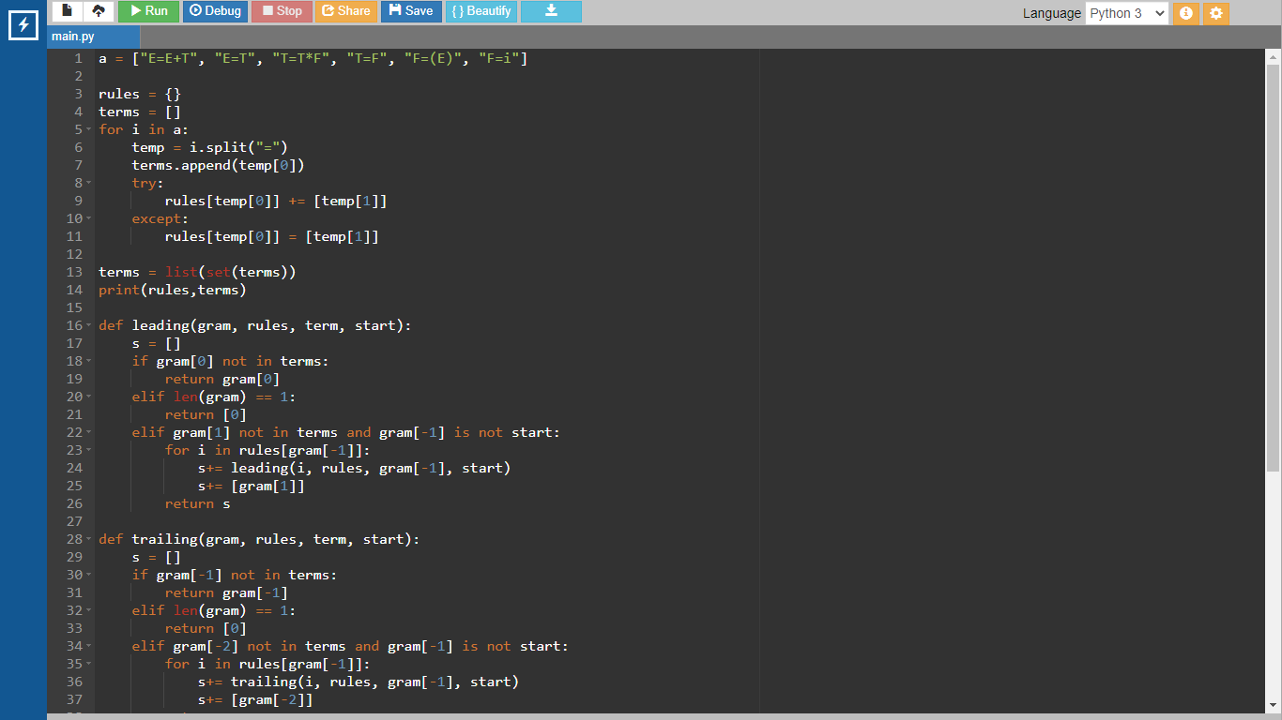

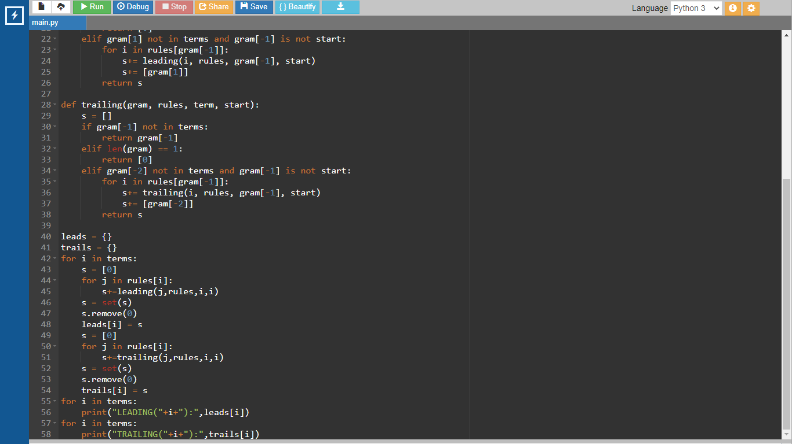

Output:

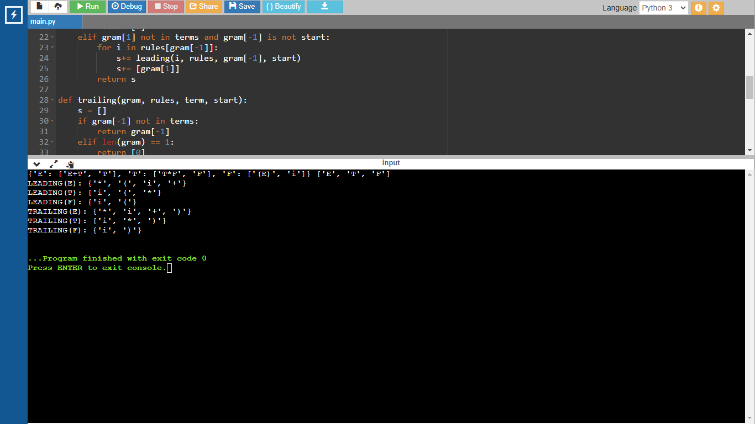

Result:

A program for Computation of leading and trailing was run successfully.